**INFRASTRUCTURE AND INVENTORY MANAGEMENT SYSTEM**

**(In-House Activity)**

**THE GREAT MIND CHALLENGE 2015**

****

**Prepared By**

**Sourabh Kumar Sukhija**

CONTENTS

[List of tables iv](#_Toc447970487)

[List of figures v](#_Toc447970488)

[CHAPTER 1 14](#_Toc447970489)

[INTRODUCTION TO THE PROJECT 14](#_Toc447970490)

[PART 1 14](#_Toc447970491)

[INTRODUCTION 14](#_Toc447970492)

[1.1 Problem Definition 14](#_Toc447970493)

[1.1.1 In Inventory Management System 14](#_Toc447970494)

[1.1.2 In Infrastructure Management System 14](#_Toc447970495)

[1.2 Objective 15](#_Toc447970496)

[1.3 Overview of Project 15](#_Toc447970497)

[1.4 Study Of Existing System 15](#_Toc447970498)

[1.5 Advantages Over Existing System 16](#_Toc447970499)

[1.6 Inventory Management 16](#_Toc447970500)

[Employee Pannel Activities: 16](#_Toc447970501)

[Admin Pannel Activities: 16](#_Toc447970502)

[1.7 Infrastructure Management 16](#_Toc447970503)

[1.8 Development Schedule 17](#_Toc447970504)

[1.9 Reason For Developing The Software 17](#_Toc447970505)

[PART 2 18](#_Toc447970506)

[SYSTEM DESIGN 18](#_Toc447970507)

[2.1 Use Case Diagram (for admin) 18](#_Toc447970508)

[2.2 Use Case Diagram (For Employee) 19](#_Toc447970509)

[2.3 Data Flow Diagram 20](#_Toc447970510)

[2.4 E.R Diagram 23](#_Toc447970511)

[2.5 Flow Chart 25](#_Toc447970512)

[2.6 Class Diagram 26](#_Toc447970513)

[2.7 Database/ Backend Diagram 27](#_Toc447970514)

[2.8 Sequence Diagram 28](#_Toc447970515)

[2.9 Activity Diagram 28](#_Toc447970516)

[CHAPTER 2 43](#_Toc447970517)

[SCREENSHOTS 43](#_Toc447970518)

[2.1 Screenshots 43](#_Toc447970519)

[Employee panel 55](#_Toc447970520)

[CHAPTER 3 60](#_Toc447970521)

[RESULTS AND DISCUSSIONS 60](#_Toc447970522)

[3.1 Testing 60](#_Toc447970523)

[3.1.1 Sign Up Page Testing 61](#_Toc447970524)

[3.1.2 Login Page Testing (For Admin) 61](#_Toc447970525)

[3.1.3 Login Page Testing (For Admin) 62](#_Toc447970526)

[3.1.4 Input Form Testing 62](#_Toc447970527)

[3.1.5 Ping Test Testing 63](#_Toc447970528)

[3.1.6 Speed Test Testing 63](#_Toc447970529)

[3.1.6 Windows Service Testing: For Email Notification 64](#_Toc447970530)

[3.1.7 Windows Service Testing: For Internet Speed Test 64](#_Toc447970531)

[3.2 Maintainance 64](#_Toc447970532)

[CHAPTER 4 67](#_Toc447970533)

[CONCLUSION AND FUTURE SCOPE 67](#_Toc447970534)

[4.1 Conclusion 67](#_Toc447970535)

[4.2 Future Scope 67](#_Toc447970536)

# List of tables

**TITLE PAGE NO**

[Table 1 Sign Up Page Testing 61](#_Toc438051297)

[Table 2 Login Page Testing (For Admin) 62](#_Toc438051298)

[Table 3 Login Page Testing (For Admin) 62](#_Toc438051299)

[Table 4 Input Form Testing 63](#_Toc438051300)

[Table 5 Ping Test Testing 63](#_Toc438051301)

[Table 6 Speed Test Testing 63](#_Toc438051302)

[Table 7 Windows Service Testing: For Email Notification 64](#_Toc438051303)

[Table 8 Windows Service Testing: For Internet Speed Test Notification 64](#_Toc438051304)

# List of figures

**TITLE PAGE NO**

[Figure 1 Functional Requirements 20](#_Toc438051524)

[Figure 2 Use Case For Admin 21](file:///C:\Documents%20and%20Settings\mohindra\Desktop\IMS%20(Recovered).docx#_Toc438051525)

[Figure 3 Use Case For Employee 22](file:///C:\Documents%20and%20Settings\mohindra\Desktop\IMS%20(Recovered).docx#_Toc438051526)

[Figure 4 Context Diagram 23](#_Toc438051527)

[Figure 5 DFD Level 1.1 23](#_Toc438051528)

[Figure 6 DFD Level 2.1.1 24](#_Toc438051529)

[Figure 7 DFD Level 2.1.2 24](#_Toc438051530)

[Figure 8 DFD Level 3.1 25](file:///C:\Documents%20and%20Settings\mohindra\Desktop\IMS%20(Recovered).docx#_Toc438051531)

[Figure 9 ER (Admin And Inventory) 26](#_Toc438051532)

[Figure 10 ER Diagram (Admin, Inventory & Employee) 27](#_Toc438051533)

[Figure 11 ER (Admin And Inventory) 28](#_Toc438051534)

[Figure 12 Class Diagram Of The Project 29](file:///C:\Documents%20and%20Settings\mohindra\Desktop\IMS%20(Recovered).docx#_Toc438051536)

[Figure 13 Class Diagram For Admin Panel 29](#_Toc438051535)

[Figure 14 Class Diagram For Employee Panel 30](file:///C:\Documents%20and%20Settings\mohindra\Desktop\IMS%20(Recovered).docx#_Toc438051538)

[Figure 15 Database Diagram 30](#_Toc438051537)

[Figure 16 Sequence Diagram Of The Project 31](#_Toc438051539)

[Figure 17 Activity Diagram Of The Project 31](file:///C:\Documents%20and%20Settings\mohindra\Desktop\IMS%20(Recovered).docx#_Toc438051540)

[Figure 18 Bootstrap 40](#_Toc438051541)

[Figure 19 Google reCAPTCHA 41](#_Toc438051542)



introduction to the project

PART 1 INTRODUCTION

PART 2 SDLC

PART 3 STSTEM DESIGN

# CHAPTER 1

# INTRODUCTION TO THE PROJECT

# PART 1

# INTRODUCTION

## 1.1 Problem Definition

### 1.1.1 In Inventory Management System

In the business world, efficiency and savings are always priorities. Inventory management software can ensure both. Tracking inventory manually on paper or in a spreadsheet document is unwieldy and unsafe. Both paper and digital files can be damaged or lost very easily. Fixed asset software is a much more secure solution. Additionally, it takes the work of calculating financial figures away from business decision-makers or employees and leaves it in the hands of sophisticated technology that can seamlessly manage vast data resources.

The problem is that the storage of information in these excel sheets does not prompt any notification or an alert message. And the admin have to remember warranty dates and AMC dates manually.

To overcome the above stated issues a new web application is developed which will perform the following tasks: -

* Display the entire Inventory.
* Prompt the notifications regarding warranty or AMC dates.
* Send the email to the users if the assets are out of warranty period.

### 1.1.2 In Infrastructure Management System

The discovery of problems in the network is not a big deal, but it is if the network is very large.

To overcome the above stated issues a new web Portal is developed along with the Inventory Management System which will perform the following tasks: -

* It allows an IT professional to supervise the individual components of a network within a larger network framework.
* Results displayed graphically that are very attractive to the user.
* It can also be able to check the current internet speed.
* The analysis of stored data of Internet speed helps to make profitable business decisions.

## 1.2 Objective

The problem is that the storage of inventory in the excel sheets or on a paper sheet is very difficult to store and manage and it does not prompt any notification or an alert message to the user. And the admin have to remember warranty dates and AMC dates manually.

To overcome the above stated issues MIS had the requirement of a software application which will perform the following tasks: -

* Display the entire Inventory.
* Prompt the notifications regarding warranty or AMC dates.
* Send the email to the users if the assets are out of warranty period.
* Monitoring of internet speed 24/7.

## 1.3 Overview of Project

**“Infrastructure/ Inventory Management System”** The portal is used to manage the entire consumable or non consumable inventory and it also helps to manage the network infrastructure. A user can view all the assets that are assigned to them at their login inbox. Auto generated email notification is also send to the registered user if the warranty/Annual maintenance contract period of any inventory that are assigned to him seems to be end.

The task of assignment of inventory to any employee is only done by the admin. If the user did not respond to the auto generated notifications then after some time period one more notification is generate to alert the admin that the concerned employee is not responding to the email and the details about the inventory also.

## 1.4 Study Of Existing System

In existing system, the storage of inventory in a spreadsheet document is unwieldy and unsafe, and this storage of data does not auto process able. More chances of redundancy of data.

In existing system, the troubleshooting of network problems are very difficult task, which is done by using the ping utility in the command prompt. The user has to remember all the commands to troubleshoot their network. The task to check the speed of the internet is done by using a web application called www.speedtest.comand they track the average internet speed manually on the paper.

## 1.5 Advantages Over Existing System

* It can use as an intranet Application.
* Automatic alert message sends to the user about the inventory.
* Providing High-Security.
* Easy Business Solutions.
* No redundancy of data.
* Auto process able.
* User can preview his/her account details like the inventory assigned to him.
* Warranty/AMC details.
* Efficient troubleshooting of network problems.
* Easy to test the speed of internet without using any third party application.

## 1.6 Inventory Management

### Employee Pannel Activities:

* Create an account then the request is awaiting for its approval by the admin.
* User can also check the details of inventories that are assigned to him in their login module.
* And the chat option is also available for the user to send messages to the admin.

### Admin Pannel Activities:

* Approve or reject the request.
* Add inventory.
* Modify inventory.
* Send/Reply the messages.

## 1.7 Infrastructure Management

This module is open to everyone. Any user can troubleshoot their network using this web portal. The result of this troubleshooting is display in real time with animated effects.

One more facility that I want to add in this module that is Network speed test module.

## 1.9 Reason For Developing The Software

* It is acceptable to users.
* Adaptable to change and conformable to the end user.
* The software will meet organizational requirements.
* The software will be implemented using the latest technology and within the specified budget and schedule.

# PART 2

# SYSTEM DESIGN

## F:\sourabh\Project Report\PR FORMAT\Documentary\Diagrams\Use Case\use_case_1.png2.1 Use Case Diagram (for admin)

Figure Use Case For Admin

## F:\sourabh\Project Report\PR FORMAT\Documentary\Diagrams\Use Case\use_case_1.png2.2 Use Case Diagram (For Employee)

Figure Use Case For Employee

**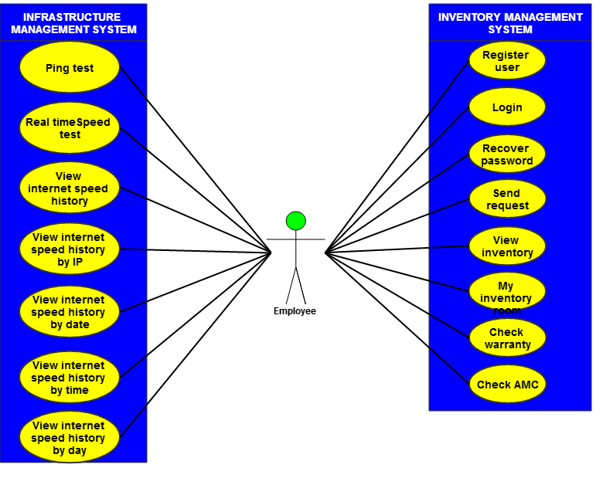**

## 2.3 Data Flow Diagram

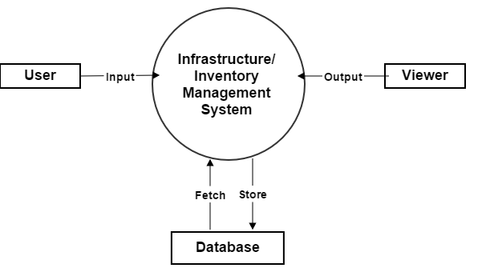

Figure Context Diagram

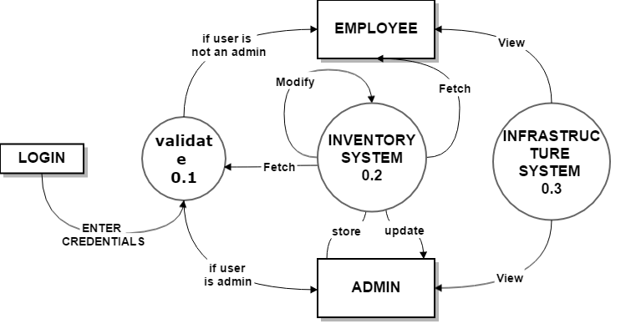

Figure 5 DFD Level 1.1

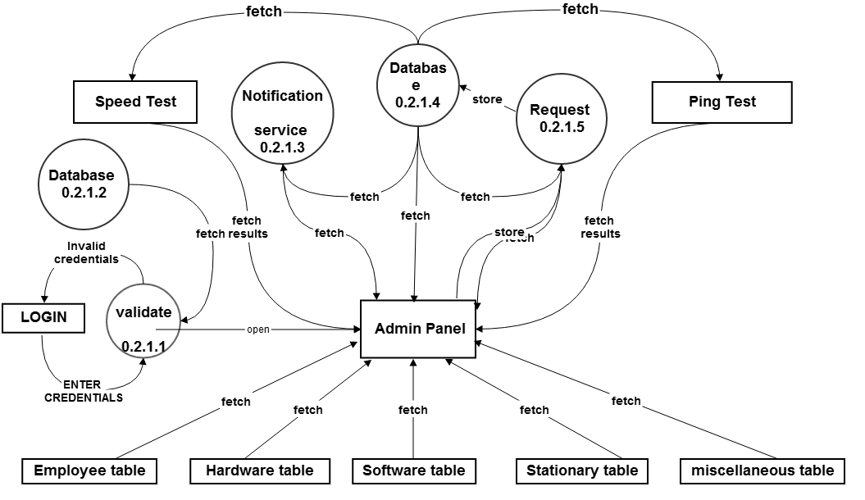

Figure 6 DFD Level 2.1.1

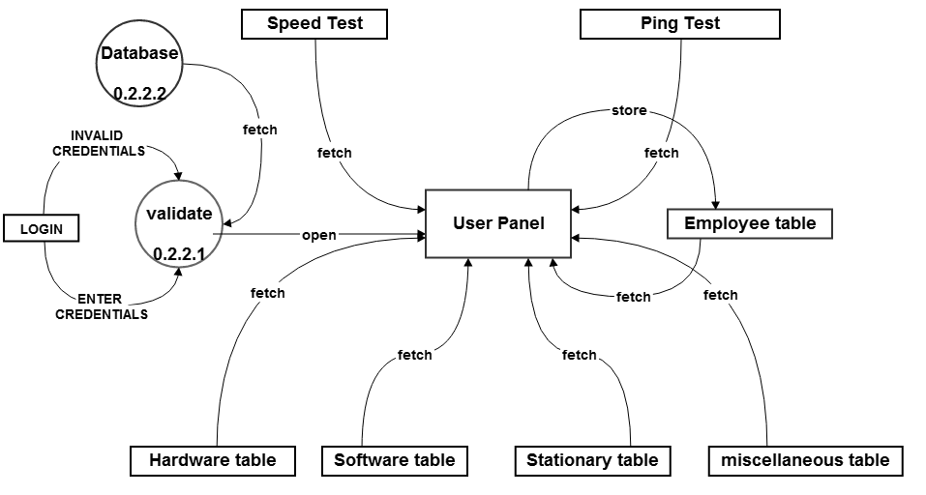

Figure 7 DFD Level 2.1.2

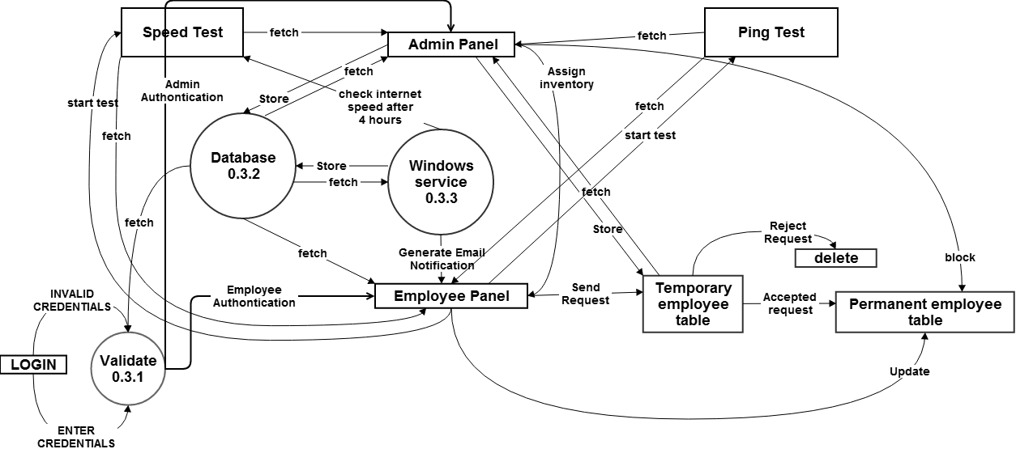

Figure DFD Level 3.1

## 2.4 E.R Diagram

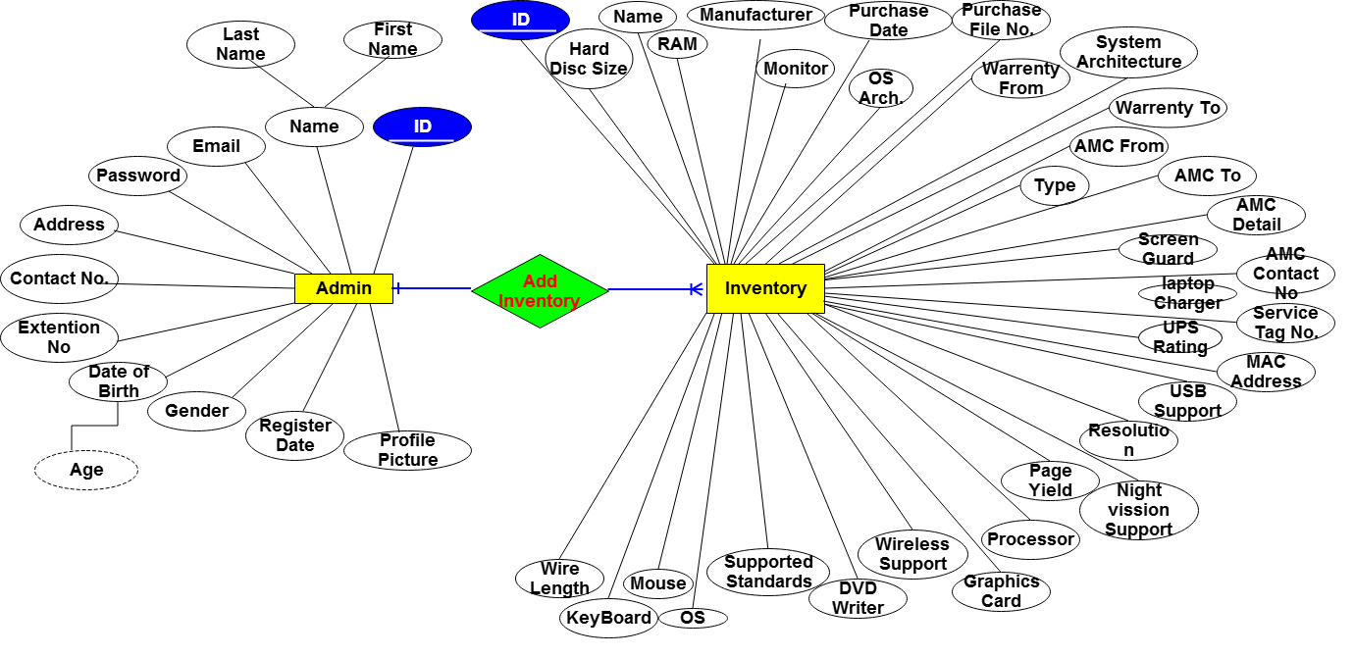

Figure ER (Admin And Inventory)

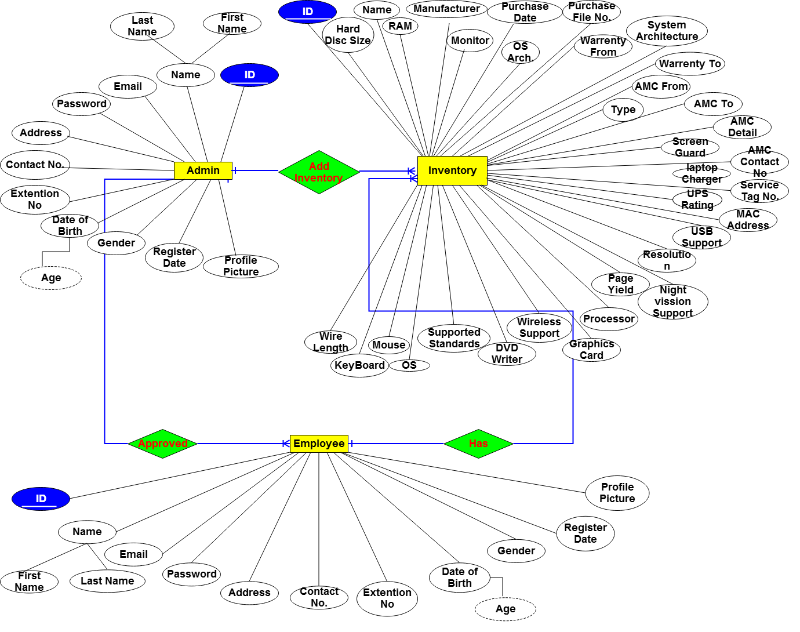

Figure ER Diagram (Admin, Inventory & Employee)

## 2.5 Flow Chart

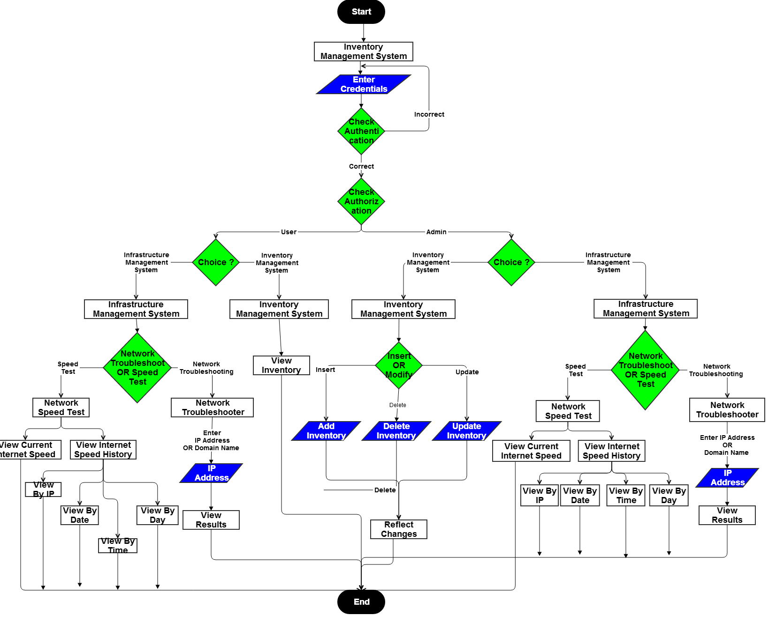

Figure ER (Admin And Inventory)

## F:\sourabh\Project Report\PR FORMAT\Documentary\Diagrams\Class Diagrams\class Diagram.PNG2.6 Class Diagram

Figure Class Diagram Of The Project

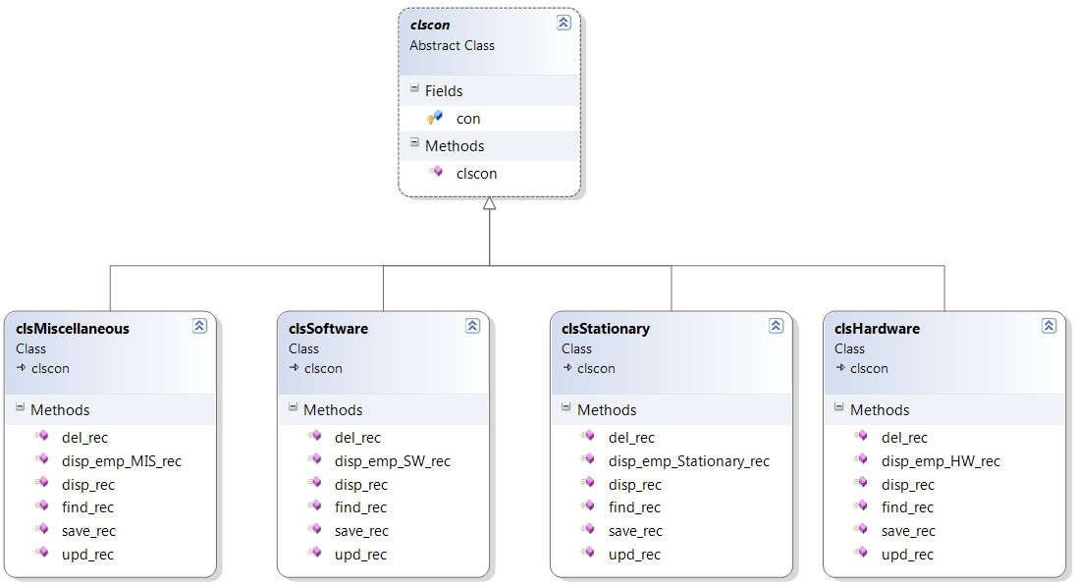

Figure Class Diagram For Admin Panel

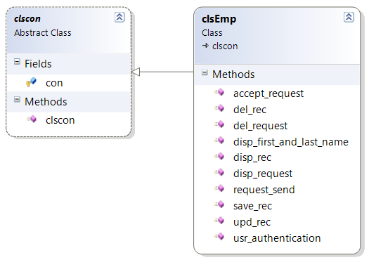

Figure Class Diagram For Employee Panel

## 2.7 Database/ Backend Diagram

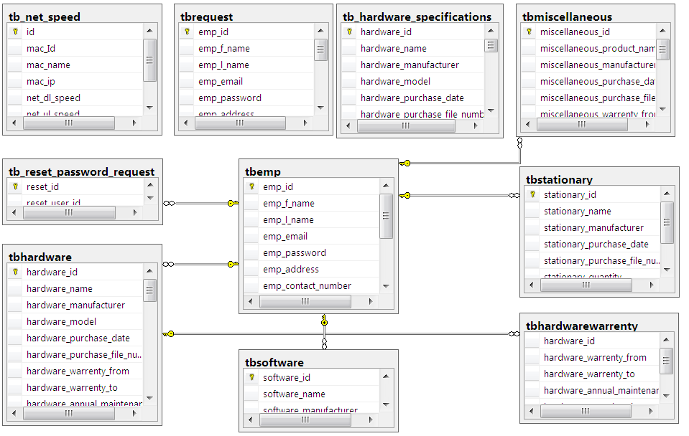

Figure Database Diagram

## F:\sourabh\Project Report\PR FORMAT\Documentary\Diagrams\Sequence Diagram\sequence_diagram.png2.8 Sequence Diagram

Figure Sequence Diagram Of The Project

## F:\sourabh\Project Report\PR FORMAT\Documentary\Diagrams\Activity Diagram\activity_diagram.png2.9 Activity Diagram

Figure Activity Diagram Of The Project



SCREENSCHOTS

2.1 Screenshots

# CHAPTER 2

# SCREENSHOTS

## 2.1 Screenshots

**Figure 3.1 Home Screen**

**Figure 3.2 Sign In**

**Figure 3.3 SignUp**

**Figure 3.4 Sign In**

**Figure 3.5 Control Panel**

Figure 3.6 Hardware Specification

**Figure 3.7 Add Hardware**

**Figure 3.8.Hardware**

**Figure 3.9 Add New Hardware**

**Figure 3.10 Select Hardware**

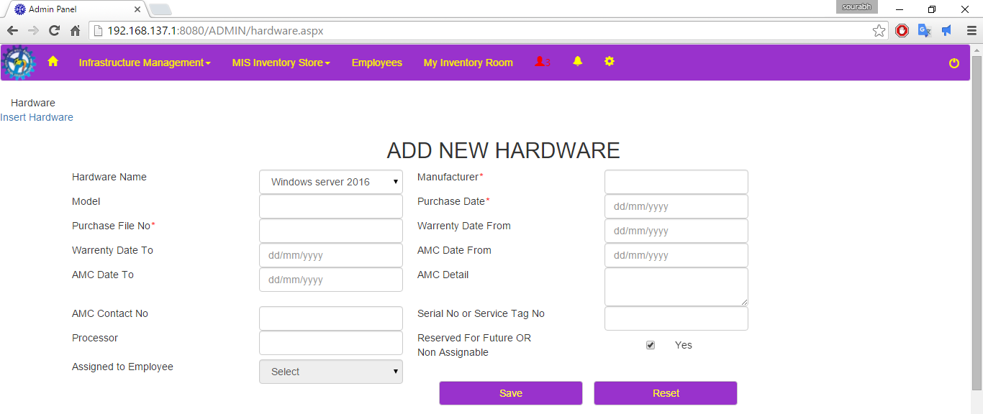

**Figure 3.11 Enter Details**

**Figure 3.12 Save Hardware**

**Figure 3.13 Export to Excel OR PDF**

**Figure 3.14 Warranty History**

**Figure 3.15 Miscellaneous**

**Figure 3.16 Software**

**Figure 3.17 Stationary**

**Figure 3.18 My Inventories**

**Figure 3.19 Notifications**

**Figure 3.20 Requests**

**Figure 3.21 Admin Home**

**Figure 3.22 Employees**

**Figure 3.23 Ping Test(start)**

**Figure 3.24 Ping Test(stop)**

**Figure 3.25 Speed Test**

**Figure 3.26 Current Internet Speed**

**Figure 3.27 Internet Speed Results Calculated By Windows Service**

## Employee panel

**Figure 3.28 Sign In**

**Figure 3.29 Employee Home**

**Figure 3.30 My Inventories**

**Figure 3.31 Ping Test(Start)**

**Figure 3.32 Ping Test(Stop)**

**Figure 3.33 Speed Test**

**Figure 3.34 Current Internet Speed**

**Figure 3.35 Internet Speed Results Calculated By Windows Service**



RESULTS AND DISCUSSIONS

3.1 Testing

3.2 Maintenance

# CHAPTER 3

# RESULTS AND DISCUSSIONS

## 3.1 Testing

Software testing can also provide an objective, independent view of the [software](http://en.wikipedia.org/wiki/Software) to allow the business to appreciate and understand the risks of software implementation. Test techniques include the process of executing a program or application with the intent of finding [software bugs](http://en.wikipedia.org/wiki/Software_bug) (errors or other defects).

It involves the execution of a software component or system component to evaluate one or more properties of interest. In general, these properties indicate the extent to which the component or system under test:

* Meets the requirements that guided its design and development,
* Responds correctly to all kinds of inputs,
* Can be installed and run in its intended [environments](http://en.wikipedia.org/wiki/Operating_environment), and
* Achieves the general result its stakeholder’s desire.

Although testing can determine the correctness of software under the assumption of some specific, testing cannot identify all the defects within software. A primary purpose of testing is to detect software failures so that defects may be discovered and corrected. Testing cannot establish that a product functions properly under all conditions but can only establish that it does not function properly under specific conditions. The scope of software testing often includes examination of code as well as execution of that code in various environments and conditions as well as examining the aspects of code: does it do what it is supposed to do and do what it needs to do. In the current culture of software development, a testing organization may be separate from the development team.

Not all software defects are caused by coding errors. One common source of expensive defects is requirement gaps, e.g., unrecognized requirements which result in errors of omission by the program designer.  Requirement gaps can often be requirements such as [testability](http://en.wikipedia.org/wiki/Software_testability), [scalability](http://en.wikipedia.org/wiki/Scalability), maintainability, [usability](http://en.wikipedia.org/wiki/Usability), [performance](http://en.wikipedia.org/wiki/Computer_performance), and [security](http://en.wikipedia.org/wiki/Computer_security).

### 3.1.1 Sign Up Page Testing

|  |  |  |  |  |  |
| --- | --- | --- | --- | --- | --- |
| **S.NO** | **INPUT DATA** | | **EXPECTED RESULTS** | **ACTUAL RESULTS** | **PASS/FAIL** |
| **FIELD NAME** | **FIELD VALUE** |
| 1. | First name: | Sourabh | Successfully signup message. | Successfully signup message. | Pass |
| Last name: | Sukhija |
| Email | Sourabh.sourabh@studentpartner.com |
| Password | 123 |
| Confirm password | 123 |
| Postal address | #90, sector-90, Delhi |
| Mobile number | 9803885555 |
| Extension no. | 413, 415 |
| DoB | 08-09-1975 |
| Gender | Male |
| Picture | “GetPersonalPhoto.jpg” |
| CAPTCHA | “I’m not a robot” |

Table Sign Up Page Testing

### 3.1.2 Login Page Testing (For Admin)

|  |  |  |  |  |  |
| --- | --- | --- | --- | --- | --- |
| **S.NO** | **STEP** | **INPUT DATA** | **EXPECTED RESULTS** | **ACTUAL RESULTS** | **PASS/FAIL** |
| 1. | Enter Email and Password | Username: [sukhija0004@gmail.com](mailto:sukhija0004@gmail.com)  Password:123 | Redirect To Admin Panel | Redirect To Admin Panel | Pass |
| 2. | Enter Email and Password | Username: [Sourabh](mailto:sukhija0004@gmail.com)  Password: 123 | Email format is incorrect | Email format is incorrect | Pass |

Table Login Page Testing (For Admin)

### 3.1.3 Login Page Testing (For Admin)

|  |  |  |  |  |  |
| --- | --- | --- | --- | --- | --- |
| **S.NO** | **STEP** | **INPUT DATA** | **EXPECTED RESULT** | **ACTUAL RESULTS** | **PASS/FAIL** |
| 1. | Enter Email and Password | Username: [anilfootware@gmail.com](mailto:anilfootware@gmail.com)  Password:  123 | Redirect To Employee Panel | Redirect To Employee Panel | Pass |
| 2. | Enter Email and Password | Username: [anil](mailto:sukhija0004@gmail.com)  Password: 123 | Email format is incorrect | Email format is incorrect | Pass |

Table Login Page Testing (For Admin)

### 3.1.4 Input Form Testing

|  |  |  |  |  |  |
| --- | --- | --- | --- | --- | --- |
| **S.NO** | **STEP** | **INPUT DATA** | **EXPECTED RESULT** | **ACTUAL RESULTS** | **PASS/FAIL** |
| 1. | Enter Inventory | Details of inventory. | Save | Save | Pass |
| 2. | Edit inventory | Edit Details of inventory. | Update | Update | Pass |
| 3. | Export to PDF | NA | Export data to PDF file | Export data to PDF file | Pass |
| 4. | Export to Excel | NA | Export data to excel file | Export data to excel file | Pass |

Table Input Form Testing

### 3.1.5 Ping Test Testing

|  |  |  |  |  |  |
| --- | --- | --- | --- | --- | --- |
| **S.NO** | **STEP** | **INPUT DATA** | **EXPECTED RESULT** | **ACTUAL RESULTS** | **PASS/FAIL** |
| 1. | Enter IP address OR Domain Name | www.google.com | Display RTT of last 20 seconds  (in milliseconds) | Display RTT of last 20 seconds  (in milliseconds) | Pass |

Table Ping Test Testing

### 3.1.6 Speed Test Testing

|  |  |  |  |  |  |
| --- | --- | --- | --- | --- | --- |
| **S.NO** | **STEP** | **INPUT DATA** | **EXPECTED RESULT** | **ACTUAL RESULTS** | **PASS/FAIL** |
| 1. | Select IP address  & search  (by date, time OR day) | 192.168.217.190 | Display downloading and uploading speed in Kilobytes | Display downloading and uploading speed in Kilobytes | Pass |

Table Speed Test Testing

### 3.1.6 Windows Service Testing: For Email Notification

|  |  |  |  |  |
| --- | --- | --- | --- | --- |
| **S.NO** | **STEP** | **EXPECTED RESULT** | **ACTUAL RESULTS** | **PASS/FAIL** |
| 1. | Automatically email fire in every 7 days to the employees whose inventories warranty period expires in next 30 days. | Receive email | Receive email | Pass |

Table Windows Service Testing: For Email Notification

### 3.1.7 Windows Service Testing: For Internet Speed Test

|  |  |  |  |  |
| --- | --- | --- | --- | --- |
| **S.NO** | **STEP** | **EXPECTED RESULT** | **ACTUAL RESULTS** | **PASS/FAIL** |
| 1. | Automatically test internet downloading & uploading speed in every 4 hours. | Test speed | Test speed | Pass |

Table Windows Service Testing: For Internet Speed Test Notification

## 3.2 Maintainance

In the maintenance I am using a SQL server’s inbuilt feature to create full database backup in incremental fashion. This will also maintain the backup of transaction log.

Apart of this I use database triggers to protect the database from unintentionally deletion. Triggers are the database events that are fire when a user insert or modify database.



Conclusion and future scope

4.1 Conclusion

4.2 Future Scope

# CHAPTER 4

# CONCLUSION AND FUTURE SCOPE

## 4.1 Conclusion

The project was started keeping in mind two aspects. Firstly the project fulfils the user’s requirement, Secondly it could be used as a utility.

The project undertaken has been successful in covering both the aspects.

Website has been developed in a neat and simple manner, thereby reducing the operators work. The user friendly nature of this website makes it very easy to work with for both the higher management as well as other employees with little knowledge of computer. The results obtained were fully satisfactory from the user point of view.

The system was verified with valid as well as invalid data in each manner.

In this portal, a user does not worry about their inventory, so if my project is being in used by MIS division then this will be definitely leads to profitable results.

The following conclusions can be drawn:

This portal is serving for the availability and alert to the user for all types of inventories like servers, hardware’s, all types of software’s, stationeries etc.

## 4.2 Future Scope

Although there is always a scope for improvement , this project has the feature for up gradation and can be easily up grated to the changing requirements as and when required and additional features can be added without interrupting the normal functioning of the Portal.